**Problem Statement**

You have been asked to:

● Add 2 nodes to Jenkins master

● Create 2 jobs with the following jobs:

○ Push to test

○ Push to prod

● Once a push is made to test branch copy git files to test server

● Once a push is made to master branch copy git files to prod server

**Solution Approach**

**Step 1: Create ec2 instances**

* We will create 3 ec2 instance: Master, Slave 1 (test server) and Slave 2 (prod server)
  + Master instance is where we download and host Jenkins
  + Slave 1 is where we will copy the file when a push is made to test branch
  + Slave 2 is where we will copy the file when a push is made to prod branch

**Step 2: Set Up a Git Repository**

* We used the Git Repository for Zendrix Softwares that was set up as part of the git assignment.
* The git repository was set up with test and main branches that would be used to trigger builds
* Link to repository: <https://github.com/vyombhatt/zendriix-softwares-workflow>
* Along with this, we will be using the same webhooks that were set up as part of the precious assignment

**Step 3: Set up the 2 Nodes on Jenkins**

1. Setting up the *test-server* node:
   * Name: *test-server*
   * Number of executors: *1*
   * Remote root directory: */home/ec2-user/jenkins/*
   * Labels: *test*
   * Usage: *Use this node as much as possible*
   * Launch Method: *Launch agents via SSH*
     + Host: *172.31.11.227 (Jenkins slave 1 private IP)*
     + Credentials: *ec2-user*
     + Host key verification strategy: *Non verifying*
   * Availability: *Keep this agent online as much as possible*
2. Setting up the *prod-server* node:
   * Name: *prod-server*
   * Number of executors: *1*
   * Remote root directory: */home/ec2-user/jenkins/*
   * Labels: *test*
   * Usage: *Use this node as much as possible*
   * Launch Method: *Launch agents via SSH*
     1. Host: *172.31.5.154 (Jenkins slave 2 private IP)*
     2. Credentials: *ec2-user*
     3. Host key verification strategy: *Non verifying*
   * Availability: *Keep this agent online as much as possible*

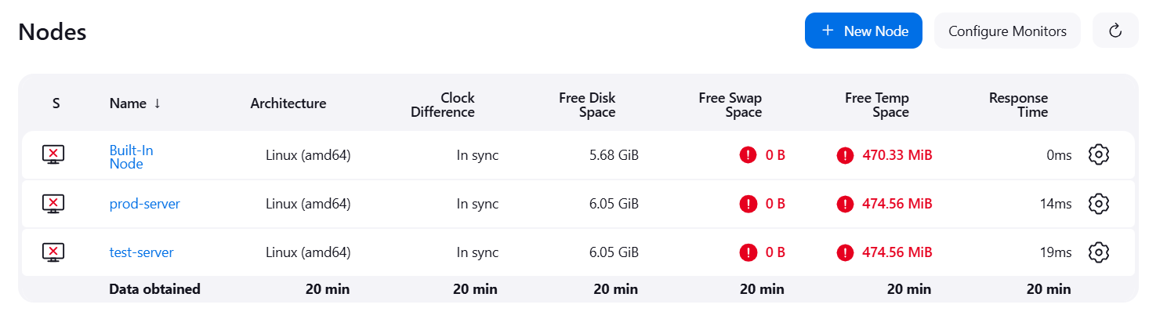

**Step 4: Set up the 2 Jobs**

1. Setting up the *push-to-test* job:
   * Create new item as freestyle project: *push-to-test*
   * Description: *trigger when a push is made to test branch*
   * GitHub project: [*https://github.com/vyombhatt/zendriix-softwares-workflow.git/*](https://github.com/vyombhatt/zendriix-softwares-workflow.git/)
   * Restrict where the project is run: *test-server*
   * Source code management
     1. Repository URL: [*https://github.com/vyombhatt/zendriix-softwares-workflow.git*](https://github.com/vyombhatt/zendriix-softwares-workflow.git)
     2. Credentials: *git credentials provided*
     3. Branch Specifier: *\*/test*
   * Build Triggers: *GitHub hook trigger for GitScm polling*
2. Setting up the *push-to-prod* job:
   * Create new item as freestyle project: *push-to-prod*
   * Description: *trigger when a push is made to main branch*
   * GitHub project: [*https://github.com/vyombhatt/zendriix-softwares-workflow.git/*](https://github.com/vyombhatt/zendriix-softwares-workflow.git/)
   * Restrict where the project is run: *prod-server*
   * Source code management
     1. Repository URL: [*https://github.com/vyombhatt/zendriix-softwares-workflow.git*](https://github.com/vyombhatt/zendriix-softwares-workflow.git)
     2. Credentials: *git credentials provided*
     3. Branch Specifier: *\*/main*
   * Build Triggers: *GitHub hook trigger for GitScm polling*

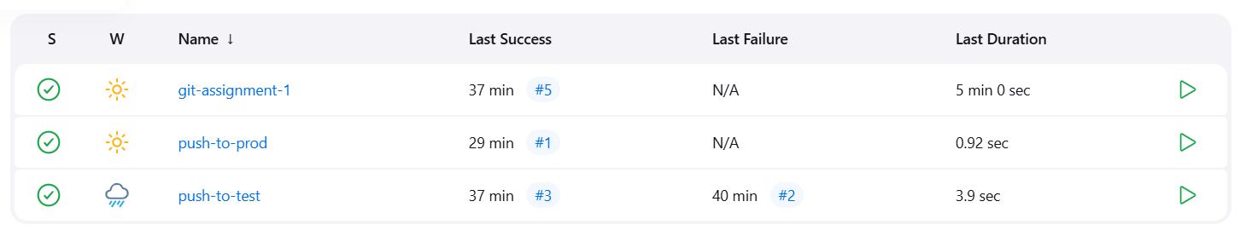

**Step 5: Testing the jobs**

Commits were made on both the branches (test and main) of the GitHub repository.

* The push command from the test branch triggered the *push-to-test* job that fetched all the files from the test branch and saved them in the *test-server*

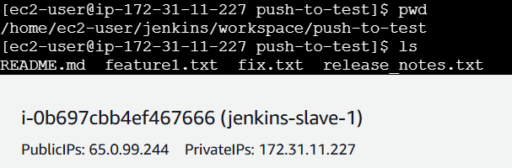

* The push command from the main branch triggered the *push-to-prod* job that fetched all the files from the main branch and saved them in the *prod-server*

